1. SQL injection vulnerability in WHERE clause allowing retrieval of hidden data

1. SQL injection vulnerability allowing login bypass

1. SQL injection UNION attack, determining the number of columns returned by the query

1. SQL injection UNION attack, finding a column containing text

1. SQL injection UNION attack, retrieving data from other tables

1. SQL injection UNION attack, retrieving multiple values in a single column

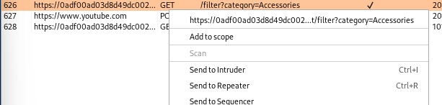

1. SQL injection attack, querying the database type and version on Oracle

1. SQL injection attack, querying the database type and version on MySQL and Microsoft

Last 2 OS labs unable to do due to not having burpsuite professional.

1. OS command injection, simple case

1. Blind OS command injection with time delays

1. Blind OS command injection with output redirection

